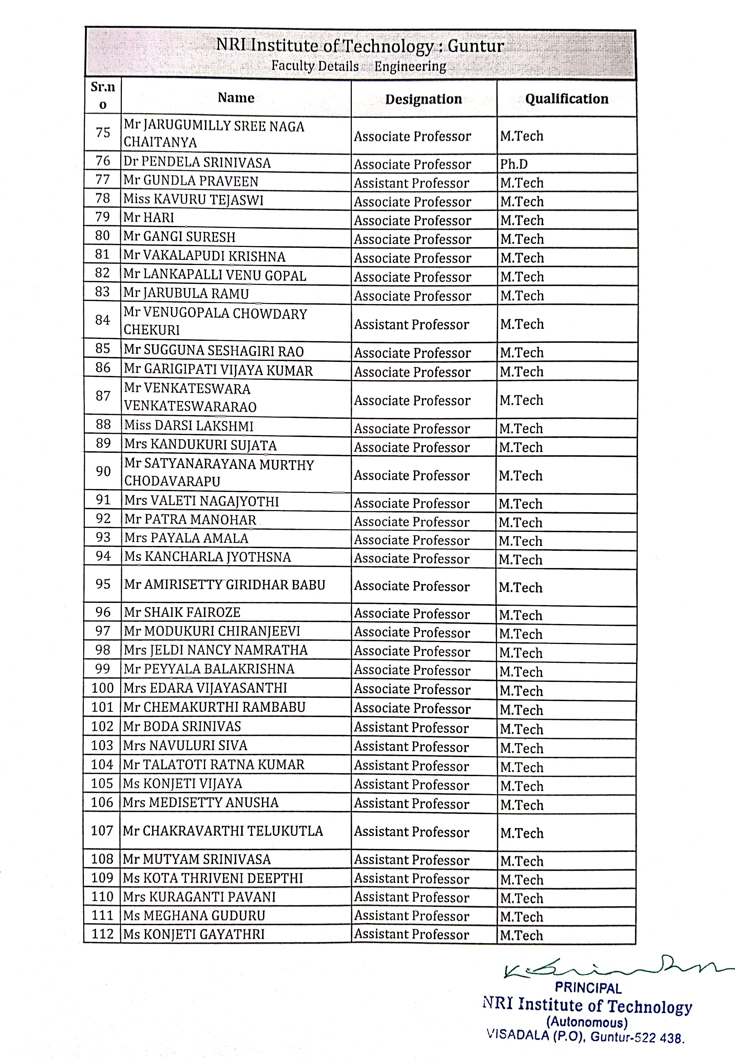

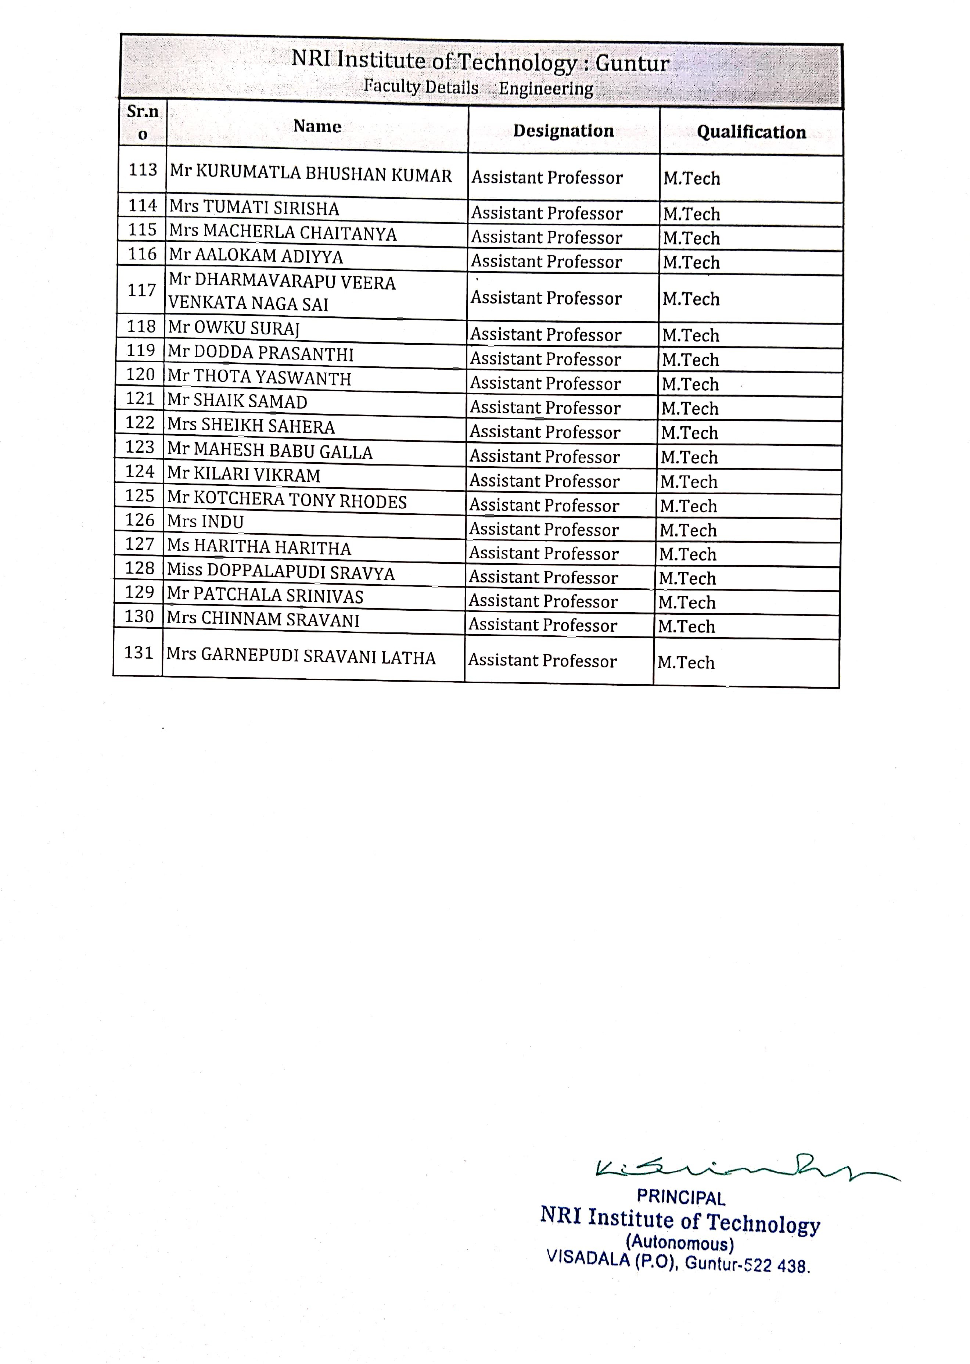

MANAGEMENT REPORT

National Institutional Ranking Framework
Ministry of Education

Government of India

(/NIRFIndia/Home)

Institute ID: IR-M-C-17990

Welcome to Data Capturing System: MANAGEMENT

Institute Name: NRI Institute of Technology, Visadala Road, Medikonda Mandal, Perecherla,PIN-522 009(CC-KP)
Full Report

Sanctioned (Approved) Intake

Academic Year | 2023-24 | 2022-23 | 2021-22 | 2020-21 | 2019-20 | 2018-19
PG [2 Years Program(s)] | 198 | 132 | --- | --- | --- | ---

Total Actual Student Strength (Program(s) Offered by Your Institution)

(All programs of all years) | No. of Male  Students | No. of Female  Students | Total Students | Within State  (Including male &  female) | Outside State  (Including male &  female) | Outside Country (Including male &  female) | Economically Backward (Including  male & female) | Socially  Challenged  (SC+ST+OBC  Including male &  female) | No. of students receiving full tuition fee reimbursement from the State and Central Government | No. of students receiving full tuition fee reimbursement from Institution Funds | No. of students receiving full tuition fee reimbursement from the  Private Bodies | No. of students who are not receiving full tuition fee reimbursement
PG [2 Years Program(s)] | 160 | 119 | 279 | 277 | 2 | 0 | 106 | 173 | 0 | 0 | 0 | 279

Placement & Higher Studies
PG [2 Years Program(s)]: Placement & higher studies for previous 3 years

Academic Year | No. of first year students intake in the year | No. of first year students admitted in the year | Academic Year | No. of students graduating in minimum stipulated time | No. of students placed | Median salary of placed graduates (Amount in Rs.) | No. of students  selected for Higher Studies
(2020-21) | 132 | 59 | (2021-22) | 42 | 12 | 600000 (six lakhs) | 30
(2021-22) | 132 | 57 | (2022-23) | 49 | 19 | 600000 (six lakhs) | 30
(2022-23) | 132 | 49 | (2023-24) | 33 | 16 | 600000 (six lakhs) | 17

Ph.D Student Details (including Integrated Ph.D)

Ph.D (Student pursuing doctoral program till 2023-24; Students admitted in the academic year 2024-25 should not be entered here.)
 |  |  | Total Students
 | Full Time |  | 0
 | Part Time |  | 0
No. of Ph.D students graduated (including Integrated Ph.D)
 |  | 2023-24 |  | 2022-23 | 2021-22
 | Full Time | 0 |  | 0 | 0
 | Part Time | 0 |  | 0 | 0

Financial Resources: Utilised Amount for the Capital & Operational expenditure for previous 3 years

Financial Year | 2023-24 | 2022-23 | 2021-22
 | Utilised Amount | Utilised Amount | Utilised Amount
Annual Capital Expenditure on Academic Activities and Resources (excluding expenditure on buildings)
Library ( Books, Journals and e-Resources only) | 118689 (0) | 160861 (0) | 68563 (0)
Expenditure on setting up/upgradation of laboratory | 410093 (0) | 1294164 (0) | 59863 (0)

Financial Year | 2023-24 | 2022-23 | 2021-22
 | Utilised Amount | Utilised Amount | Utilised Amount
Other expenditure on creation of Capital Assets (For setting up  classrooms, seminar hall, conference hall , library excluding expenditure on Land ,Building, Roads etc.) | 445615 (0) | 858977 (0) | 363513 (0)
Annual Operational Expenditure
- Salary of Teaching Staff  - Salary of Non Teaching Staff | 11053699 (0) | 8723363 (0) | 7231650 (0)
Maintenance of Academic Infrastructure or consumables and other running expenditures (excluding maintenance of hostels and allied services,rent of the building, depreciation cost, etc) | 13011558 (0) | 12114711 (0) | 8766378 (0)
National/ International level Seminars/Conferences/ Workshops/Symposia conducted by the institute | 24357 (0) | 21896 (0) | 17126 (0)

Sponsored Research Details (Only related to MANAGEMENT)

Financial Year | 2023-24 | 2022-23 | 2021-22
Total no. of Sponsored Projects | 0 | 0 | 0
Total no. of Funding Agencies | 0 | 0 | 0
Total Amount Received (Amount in Rupees) | 0 | 0 | 0
Amount Received in Words | Zero | Zero | Zero

Consultancy Project Details (Only related to MANAGEMENT)

Financial Year | 2023-24 | 2022-23 | 2021-22
Total no. of Consultancy Projects | 0 | 0 | 0
Total no. of Client Organizations | 0 | 0 | 0
Total Amount Received (Amount in Rupees) | 0 | 0 | 0
Amount Received in Words | Zero | Zero | Zero

Executive Development Programs/Management Development Programs

Financial Year | 2023-24 | 2022-23 | 2021-22
Total no. of Executive Development Programs/ Management Development Programs | 0 | 0 | 0
Total no. of Participants | 0 | 0 | 0
Total Annual Earnings (Excluding Lodging & Boarding Charges) (Amount in Rupees) | 0 | 0 | 0
Total Annual Earnings in Words | Zero | Zero | Zero

PCS Facilities: Facilities of physically challenged students

1. Do your institution buildings have Lifts/Ramps? | Yes, more than 80% of the buildings

2. Do your institution have provision for walking aids, includingwheelchairs and transportation from one building to another for handicapped students? | Yes
3. Do your institution buildings have specially designed toilets for handicapped students? | Yes, more than 80% of the buildings

Faculty Details

Srno | Name | Age | Designation | Gender | Qualification | Experience (In Months) | Currently working with institution? | Joining Date | Leaving Date | Association type
1 | Mr HANUMANTHA RAO THALLAM | 48 | Professor | Male | MCA | 112 | Yes | 16-11-  2022 | --- | Regular
2 | Dr KUMARI GUNTUPALLI | 50 | Professor | Female | Ph.D | 256 | Yes | 08-11-  2021 | --- | Regular
3 | Dr REHMAN ZIA | 44 | Professor | Male | Ph.D | 241 | Yes | 01-06-  2010 | --- | Regular
4 | Dr VETAPALEM CHENCHU | 46 | Professor | Male | Ph.D | 68 | Yes | 08-11-  2021 | --- | Regular
5 | Mr ARUN | 38 | Assistant Professor | Male | MBA | 40 | Yes | 18-03-  2024 | --- | Regular
6 | Mrs NALLA SIRISHA | 36 | Assistant Professor | Female | MBA | 70 | Yes | 08-09-  2021 | --- | Regular
7 | Mrs PAMIDIMUKKALA ANUPAMA | 40 | Associate Professor | Female | MBA | 203 | Yes | 09-08-  2010 | --- | Regular

8 | Mr SHAIK NAZEER | 30 | Assistant Professor | Male | MBA | 66 | Yes | 20-01-  2022 | --- | Regular
9 | Mrs GAJAVELLI RANJITHA | 30 | Assistant Professor | Female | MBA | 80 | Yes | 09-11-  2020 | --- | Regular
10 | Mr RAO SUDA | 42 | Associate Professor | Male | MBA | 56 | Yes | 15-11-  2022 | --- | Regular
11 | Mrs KARNATI NAGA LAKSHMI | 35 | Assistant Professor | Female | MBA | 149 | Yes | 09-02-  2015 | --- | Regular
12 | Mr MANDADA RAVI | 62 | Assistant Professor | Male | MBA | 165 | Yes | 01-10-  2013 | --- | Regular
13 | Mrs BOLLISETTI ARCHANA | 36 | Assistant Professor | Female | MBA | 68 | Yes | 11-11-  2021 | --- | Regular
14 | Mr BALIJEPALLI VENKATA | 33 | Assistant Professor | Male | MBA | 134 | Yes | 02-05-  2016 | --- | Regular
15 | Mrs SUSI SOWMY | 33 | Assistant Professor | Female | MBA | 109 | Yes | 04-06-  2018 | --- | Regular
16 | Mr THELAGATHOTI ANIL KUMAR | 53 | Assistant Professor | Male | MBA | 108 | Yes | 02-07-  2018 | --- | Regular
17 | Ms THOTA NAGA BHARGAVI | 33 | Assistant Professor | Female | MCA | 121 | Yes | 03-06-  2017 | --- | Regular
18 | Mr CHILAKA BALA | 36 | Assistant Professor | Female | MCA | 121 | Yes | 01-06-  2017 | --- | Regular
19 | Mr IMMADISETTY SURESH BABU | 47 | Associate Professor | Male | MCA | 122 | Yes | 24-05-  2017 | --- | Regular
20 | Mrs TALATHOTI SUJATHA | 42 | Assistant Professor | Female | M.A | 121 | Yes | 01-06-  2017 | --- | Regular

21 | Mr KRISHNA GADDAM | 31 | Assistant Professor | Male | MCA | 102 | Yes | 07-01-  2019 | --- | Regular
22 | Ms GUDE NANDINI | 32 | Assistant Professor | Female | MCA | 80 | Yes | 09-11-  2020 | --- | Regular
23 | Mr GOLLAPUDI RAJASEKHAR | 34 | Assistant Professor | Male | M.A | 66 | Yes | 11-01-  2022 | --- | Regular
24 | Mr A AKULA | 61 | Assistant Professor | Male | MCA | 80 | Yes | 16-11-  2020 | --- | Regular
25 | Mrs POLU NALINI | 38 | Assistant Professor | Female | MCA | 47 | Yes | 11-08-  2023 | --- | Regular
26 | Mr KHAJA VALI | 21 | Assistant Professor | Male | MCA | 7 | Yes | 02-09-  2024 | --- | Regular

